04/14/2022 第九週 線上教室

時間過得很快，學期已過了一半，上正課時間只剩一個多月，第15週(05/26)發期末考試題(線上公布)，第16週(06/02)交卷，第17週(06/09)交報告，尚未完成者可以延至第18週繳交。報告題目如仍未確定，應儘快決定。原則上任何題材都可以考慮。現階段疫情對美國乃至世界局勢的影響、俄烏戰爭背後的美國主導以及制裁措施引發美國本身的經濟危機，這些都對11月美國期中選舉有相當影響，2008年歐巴馬、拜登當選正、副總統，民主黨同時贏得參眾兩院多數，但2010年期中選舉的結果民主黨失去眾議院多數，Pelosi直到八年後2018年川普總統上任後的期中選舉才奪回眾院多數，回任議長，期中選舉向來都對總統的政黨不利，參議院目前兩黨各半的局面能否在11月選舉後持續，是拜登政府目前最大的考驗。以上這些都可以考慮作為報告取材的範圍。大家要把握時間。

接下來繼續介紹2013參議院核子選擇引爆後提名案停止討論動議的程序變化及其影響。

2013年「核子選擇」

D.C. Circuit三法官提名案受阻

2013年3月6日上午包練針對中情局局長柏潤提名案冗長發言之前，參議院曾針對歐巴馬總統提名哥倫比亞區巡迴上訴法院(D.C. Circuit)法官候選人黑莉根(Caitlin Joan Halligan)的停止討論案進行表決，由於共和黨抵制，停止討論以51比41並未通過， 3月22日白宮遂撤回提名案。此一上訴法院職位係因原任法官羅伯(John G. Roberts, Jr.)在2005年9月升任聯邦最高法院院長(Chief Justice)而來，懸缺已長達近8年。黑莉根提名案撤回後，歐巴馬總統於6月4日另行提名米樂(Patricia Ann Millett)接任此一法官職務。對多數黨領袖瑞德而言，半年來兩度目睹共和黨新進參議員的冗長發言能力，如不能突破這超級多數的障礙，提名案勢必原地踏步。8月1日米樂提名案(PN527-113)在參院司法委員會通過，10月28日傍晚多數黨領袖瑞德在院會將提名案提出，隨即提出停止討論動議，10月31日中午，停止討論案以55比38落敗(Vote Number:227)，多數黨領袖瑞德隨即提出復議動議 (a motion to reconsider the vote by which cloture was not invoked on the nomination of Ms. Millet.)，但僅列入紀錄 (The motion is entered.)。以下是國會紀錄摘錄：

**S7708 CONGRESSIONAL RECORD—SENATE** *October 31, 2013*

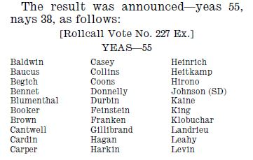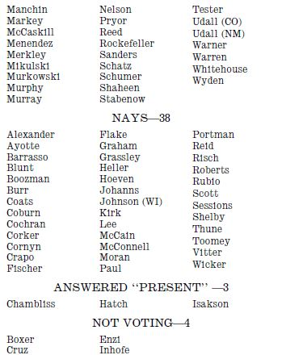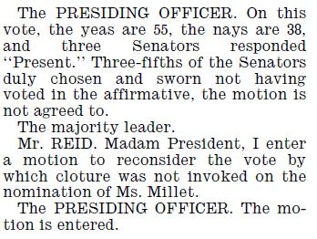

哥倫比亞區巡迴上訴法院辦案法官(Active judges)共計11席，當時共懸缺3席，其餘8席中4席為民主黨總統提名(Clinton 3, Obama 1)、4 席為共和黨總統提名(H.W. Bush[老布希] 1, W. Bush[小布希] 3)，歐巴馬亟欲填補3 席空缺，但這將破壞上訴法院原先的意識形態平衡(左右兩派各四席)，因此共和黨人不願在提名案上讓步。

除米樂以外，另外兩席法官缺，歐巴馬總統在6月4日同時亦提名琵拉(Cornelia T. L. Pillard)、韋根(Robert Leon Wilkins)兩人。10月31日米樂案受阻後，多數黨領袖瑞德承受民主黨同僚及自由派利益團體強大壓力，便考慮要以強硬手段處理這三席法官提名案。

11月7日琵拉案( PN528-113)提至參院院會，12日停止討論案同樣以56比41否決；韋根案(PN529-113)接著在14日提至院會，18日停止討論案又以53比38否決。由於共和黨毫不讓步，當年的14人幫也陸續引退凋零，共和黨只剩3人(Susan Collins (R-ME), Lindsey Graham (R-SC), John McCain (R-AZ).)，民主黨只剩2人(Mary Landrieu (D-LA), Mark Pryor (D-AR).)，缺少強大的溫和派居中介入，核子選擇遂接著引爆。

「核子選擇」是指此種作法如同以核武摧毀參議院的保障少數權利傳統，其具體操作，是以提出秩序問題的方式，主張某一程序錯誤(此處為停止討論動議的門檻應降低至簡單多數而非超級多數)，經主席裁決秩序問題不成立(因為依22號規則應為超級多數)，議員提出申訴動議，要求推翻主席原裁決，表決結果申訴動議獲勝(因為多數黨仍掌握過半數票)，原裁決被推翻，所形成的新(程序)決定即成為「先例」或「慣例」，這是一種規則中沒有規定的內容，是一種規則的補充。

2013，2017民主、共和兩黨先後變更提名案停止討論動議的門檻，均係以此種操作方式完成。

關於秩序問題、申訴動議的簡單說明，附錄於此：

以下錄自議會法標準典範 (譯自Sturgis Standard Code of Parliamentary Procedure, 1950. pp.205-211.)

第七章 偶發動議

第二節 秩序問題

◎目的

秩序問題之目的，在喚起主席與大會對破壞規則(a violation of the rules)，或遺漏問題(or to an omission)或議事程序錯誤(or to a mistake in procedure)之注意，並經由主席的裁定，使會議進行能嚴格遵守會議規則。

◎方式

提出者（毋需討得發言地位）「主席，我提出秩序問題。」

主席（不待附議）：「請說明秩序問題。」

提出者：「我的秩序問題是剛才所提的動議是不合序的，因為有另

一主動議在場。」

主席：「你的秩序問題成立，剛才所提的動議不合秩序。」

或

「你的秩序問題不成立，現在並無另外主動議在場進行。請

發言者（為秩序問題所中斷之發言者）繼續發言。」

◎說明

執行大會所有之規則和議會法，是主席之任務。發現破壞規則之每一會員，有權要求主席徹底執行規則。

秩序問題，必須在錯誤、違規，或遺漏問題(The mistake，error，or omission)發生之後立刻提出。但對觸犯法律，違背章程或細則(A violation of the law or of the constitution or bylaws)的錯誤，則無論何時提出均不為遲。

秩序問題之提出，等於要求主席給予所提觀點之裁定(That the presiding officer give a ruling or decision on the point which the member raises)。

由於秩序問題如此重要，故在未改正其錯誤前，任何動議都不能處理。秩序問題，無論何時皆可提出。即使是有人討得發言地位時，亦可提出。提出者說明其所提之秩序問題，以便主席了解其質詢，而授予發言權利。一俟提出者說明其秩序問題，主席必須予以裁定，即對秩序問題之成立與否予以決定，如有必要，說明其裁定理由。

如果主席對秩序問題發生懷疑，或者不願負起裁定之責任，可以與議會法顧問或其他人協商，或以下列方式將其交付大會決定：

『甲會員提出秩序問題，認為剛才所提修正動議與以前所提者相同(That the amendment just proposed is the same as an amendment already defeated)。我對此發生懷疑，現在將該質詢提請大會決定。此問題是：「此修正動議（宣讀之）是否與本日下午稍早所否決之修正動議相同？」認為與其相同者請答應「相同」……反對與其相同者請答應「不相同」，相同者通過(Those who believe that it is the same say, ‘Aye.’…Those who believe that it is not the same, ‘No.’ The decision is in the affirmative;)，此修正動議不合序(The amendment, therefore, is declared out of order.)。』

如有必要，主席可將秩序問題提請大會討論。無論如何，除非主席請求，或提出申訴動議，秩序問題不能討論。如會員希望對秩序問題之裁定討論或詰難，必須首先提出申訴動議。

如秩序問題提出一個特別複雜或非常重要之問題，主席無法裁定時，可以向會眾說明，在參閱判例後再予裁定(He may state that his decision will be deferred until he has had opportunity to do research and to examine precedents.)。如果對秩序問題之裁定因此延緩，而與秩序問題有關之議案，亦應延緩處理。

◎效力

秩序問題提出後，可以間斷所有議事，一直到裁定後為止。如主席認為秩序問題適當，即糾正在場之錯誤。如認為並非適當，即從間斷之點恢復議案之處理。

◎秩序問題之規則

1.可以間斷發言者之發言，因其錯誤必須立刻糾正。

2.不需附議，因係一個問題或要求，而非一個正式動議。

3.除非主席將其交付大會討論，秩序問題不能討論。

4.不能修正，因係一種要求，而非一個正式動議。

5.不需表決，因其並非是正式動議。

6.有偶發動議之優先順序，除特權動議外優先於所有動議。

7.可以對任何錯誤、違規或遺漏提出。

8.除收回動議外，任何動議均不能對秩序問題提出。對其裁定，可以提出申訴動議。

第一節 申訴動議

◎目的

對主席裁定提出申訴之目的，在使不服主席裁定之會員，能將主席的裁定申訴於眾，以決定主席的裁定是維持抑或推翻。

◎方式

動議者（在主席裁定之後毋需討得發言地位立即提出）：「主席，我對主席之裁定提出申訴。」

主席：「主席的裁定已被申訴，請申訴者說明申訴的理由。」

主席可以在申訴動議討論之前，或討論之後，說明其裁定理由。申訴動議應如此宣付表決：

「維持主席裁定者請答應『贊成』……反對主席裁定請答應『反對』……主席裁定被維持(或被推翻)(Those in favor of sustaining the decision of the chair say, ‘Aye.’…Those opposed, ‘No.’…The decision of the chair is sustained [or overruled].)」。

◎說明

申訴動議，是會眾審議主席裁定之方法(The means by which an assembly may review the decisions of its presiding officer)。主席之任何裁定，皆可能受到申訴。對議事詢問之答覆或表決結果之宣佈，並非是一種裁定，所以不能申訴。

任何申訴動議，必須於裁定之後立即提出。如果有任何其他議案相間，或討論中已有了進展，申訴動議就不能提出。如果有會員想提出申訴，但有另一位會員為了其他目的而取得發言地位，則申訴者可以中斷其發言，迅速提出申訴。

申訴動議可以討論。早期議會法作者認為對於指出有關動議優先順序與有關發言規則之申訴不能討論，但是根據既有之實例來看，所有申訴，均可在表決之前，予以討論。主席說明其裁定理由時，不必離開主席地位。

如會員對申訴理由之陳述，證明主席之裁定並不正確，主席可自行改變其裁定，於是此項申訴就自動取銷(The chairman himself may reverse his decision，where upon the appeal is automatically dropped.)。

有些立法機關，准許將申訴動議暫時延期，以便予以壓制，並且不准將其再行恢復討論。在一般會議，這種程序並不適用，而且大會之直接表決，是處理申訴動議終極方法。

主席之裁定，可由合法參加表決之多數或可否相同之票數，而予以維持。可否同數之所以能夠維持主席裁定之理由，乃是因為欲推翻主席之裁定，必須合法參加表決之多數人反對主席裁決方可為之。主席如係會員，可以參予表決，以維持其裁定。

◎效力

申訴動議，在將主席之裁定交付大會批准或否決。如果主席之裁定得到維持，其裁定即成為大會之裁定。如果主席之裁定未得到維持，其裁定就被推翻。

主席對秩序問題之裁定和大會關於申訴之決定，是議事判例之重要淵源，基於這些判例，議會法才能逐漸發展成長(Rulings by the presiding officer on points of order and decisions of the assembly on appeals are an important source of precedents by which parliamentary law is developed.)。

◎申訴動議之規則

1.可以間斷發言者之發言，因其需要立刻決定而且有提出時間之限制。

2.需要附議，因其效力等於推翻主席裁定。

3.可以討論。

4.不能修正，因其形式不能改變。

5.需要合法參加表決之多數或同數，始能維持主席之裁定。

6.具有偶發動議之優先順序，除特權動議外，優先於其他所有動議。

7.不能對任何動議提出，但是可以對主席裁定提出。

8.對申訴動議可以提出暫時延期，延期討論動議，立付表決、限制討論動議以及收回動議。

11月21日「核子選擇」引爆

10月底米樂提名案遭杯葛三週之後，多數黨領袖瑞德在11月21日發動攻擊。21日上午10時30分院會開會，兩黨領袖就法官提名應否變更參院傳統的主題各抒己見之後，瑞德將10月31日停止討論案的復議動議提出。

此一程序的攻防分為三階段，首先要使31日停止討論的表決結果失效，亦即復議動議要能通過，停止討論案就須重新表決；接著便以秩序問題、主席裁定、申訴動議推翻裁定的操作方式，重新定義提名案停止討論案的門檻(由60票降至表決過半數)，這也就是核子選擇；最後再依新的表決門檻重新表決停止討論案，停止討論以簡單多數通過後提名案即可順利表決、順利通過。

第一部分計有三次表決：針對能否提出復議動議的進行考慮動議(to proceed to consideration)在11時8分以57比40通過(Vote Number: 239)，共和黨領袖麥康納隨即動議散會至下午5時，散會動議在11時29分以48比52否決(Vote Number: 240)，復議動議接著在11時46分以57比43通過(Vote Number: 241)。復議通過的結果，使米樂提名案的停止討論動議回到表決前狀態。

Vote 239、 vote 241 國會紀錄摘錄

Vote 239進行考慮動議

**S8416-17 CONGRESSIONAL RECORD—SENATE** *November 21, 2013*

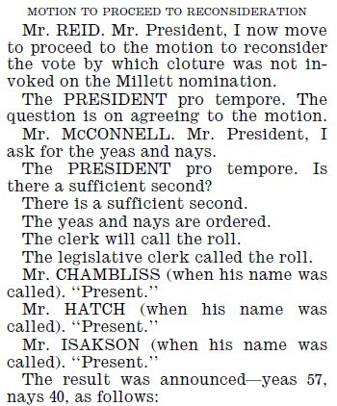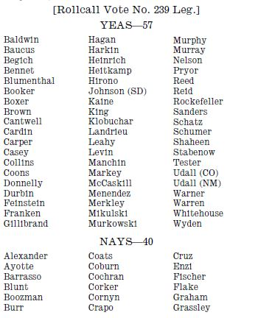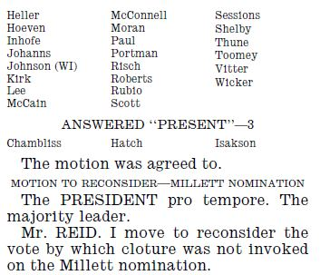

vote 241復議動議

*November 21, 2013* **CONGRESSIONAL RECORD—SENATE S8417**

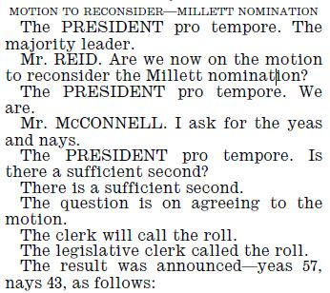 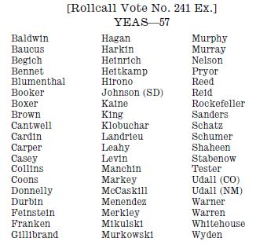 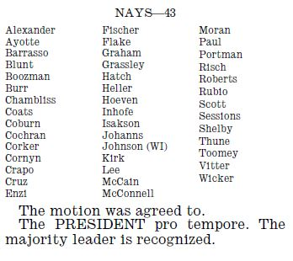

進入第二部分後共和黨已無力阻擋，瑞德在此時提出秩序問題，認為「除最高法院大法官以外，所有提名案停止討論之表決，依22號規則均應以表決多數為之」(“that the vote on cloture under rule XXII for all nominations other than for the Supreme Court of the United States is by majority vote.”)。主席接著裁定秩序問題不成立(is not sustained)，瑞德隨即動議申訴主席裁定，12時10分主席原裁定以48比52撤銷(Vote Number: 242)，申訴獲勝。

此時新慣例已經建立，共和黨領袖麥康納雖然接著也提出秩序問題，質疑新慣例與參院規則不一致，提名案停止討論門檻仍應為參院全體3/5，但主席順勢依新慣例裁定麥康納的秩序問題不成立，麥康納雖提出申訴，12時35分表決結果仍以52比48確定了主席裁定(Vote Number: 243)。

Vote 242、 vote 243 (兩次申訴主席裁定) 國會紀錄摘錄

*November 21, 2013* **CONGRESSIONAL RECORD—SENATE S8417**

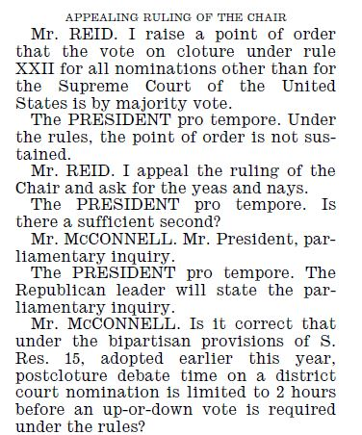 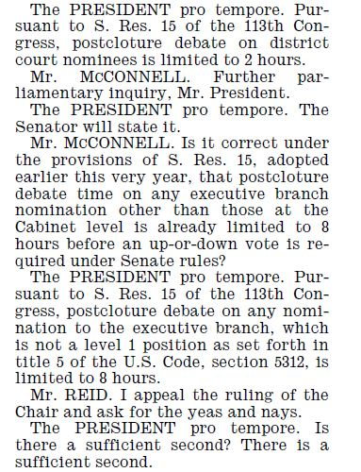 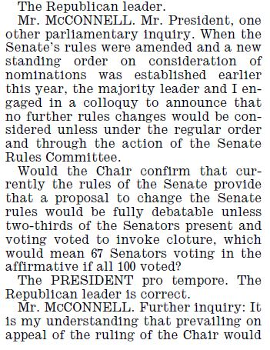

**S8418 CONGRESSIONAL RECORD—SENATE** *November 21, 2013*

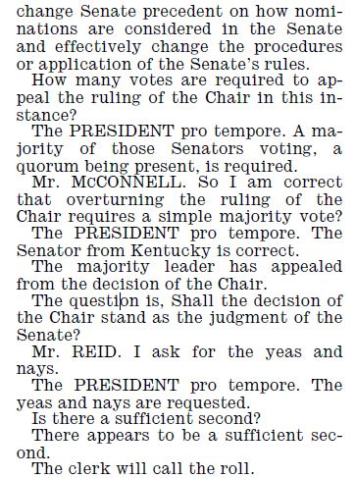 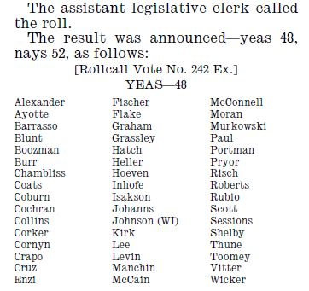 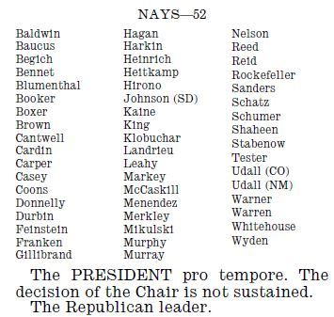

**S8418**

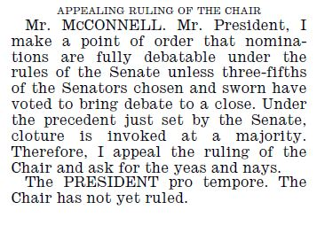 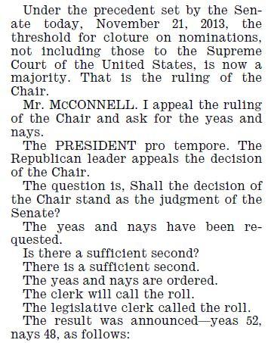 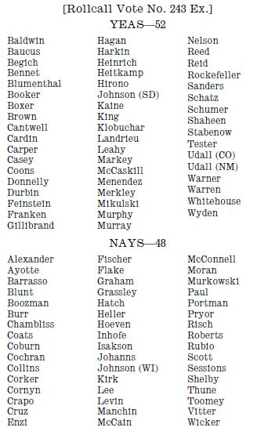

The PRESIDENT pro tempore. The Senate sustains the decision of the Chair.

The majority leader.

接下來就是依新表決標準(過半數即可通過) 重新表決(即復議) 的待決停止討論動議 pending cloture motion, vote 244國會紀錄摘錄

**S8418**

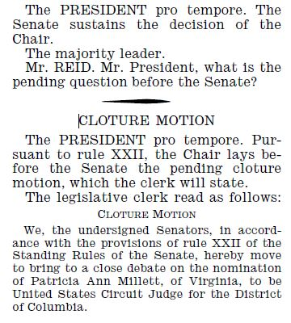 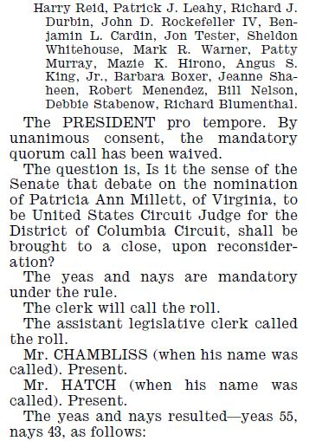 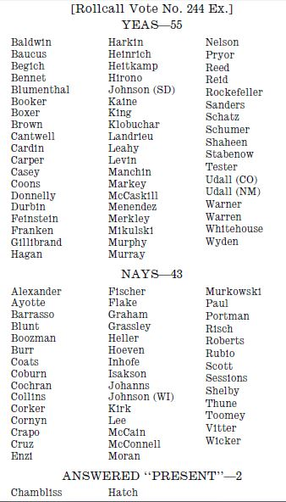

The PRESIDENT pro tempore. Upon reconsideration, the motion is agreed to.

核子選擇的影響範圍

超級多數的停止討論門檻既已經核爆摧毀，停止討論動議遂於12時57分以55比43通過(Vote Number: 244)，米樂與琵拉提名案在12月10日先後通過，韋根案也在2014年1月13日通過。11月21日參議院新慣例的影響，要比2005年共和黨領袖傅力胎死腹中的核子選擇來的大，除了法官提名案以外，此後所有其他提名案均僅需簡單多數即可停止討論，少數黨不再有能力阻擋總統的提名選擇(最高法院除外)，受影響的職位總計達1,183人。

21日建立新慣例的申訴案表決中，並非所有民主黨參議員都支持瑞德，有三位民主黨參議員(Carl Levin(D-MI), Joe Manchin III(D-WV), Mark Pryor(D-AR).)在申訴案表決時支持共和黨。

2005年首先提出「核子選擇」一詞的前共和黨領袖辣德(Trent Lott 1997-2001為多數黨領袖，2001-2003為少數黨領袖，其繼任者即Bill Frist.)，在民主黨把「核子選擇」變成事實後指出：「這樣做是錯的…參議院是個獨特的機構，規則不論多累贅而困難，也比將它(參院)變成另一個眾議院要好」(“It was mistake when we were talking about doing it,” “I still believe the Senate is a unique institution and the rules – no matter how cumbersome and difficult – are better than just making it another House of Representatives.”)對於民主黨領袖瑞德的作為，辣德只說：「我了解你的感受…但你將來一定會後悔。」(I know how you feel, but trust me, you are going to regret this.)

2014年期中選舉共和黨贏得參議院多數，2016年大選川普當選總統，共和黨重新掌控立法與行政二者，2017年元月川普總統提名聯邦最高法院大法官Neil M. Gorsuch，提名案於四月在參院院會討論，因民主黨杯葛，共和黨領袖遂以2013年民主黨操作核子選擇的相同手法，將最高法院大法官提名案停止討論的門檻降低，詳情請參閱 2017 nuke filibuster PN55-115.ppt 以及國會紀錄

CREC-(Legislative day of Tuesday, April 4, 2017) 2017-04-06-senate-bk3-S2388-S2391.pdf

CREC-2017-04-07-pt1-PgS2436-3.pdf

2017年4月6日參議院共和黨人的作法與2013年11月21日民主黨多數的作法如出一輒。

首先依舊例表決Gorsuch提名案的停止討論動議 (cloture)，55 vs. 45 否決

Vote No. 105 **S2389** *April 6, 2017* **CONGRESSIONAL RECORD—SENATE**

共和黨領袖McConnell 提出復議動議 (Motion to Reconsider)，55 vs. 45 通過

Vote No. 106 **S2389**

民主黨領袖Schumer 動議提名案延期至4月24日下午3時，48 vs. 52 否決

Vote No. 107 **S2389**

共和黨領袖McConnell 提出秩序問題：依2013年11月21日前例，所有提名案停止討論之表決均為多數表決(表決過半數)。

I raise a point of order that the vote on cloture, under the precedent set on November 21, 2013, is a majority vote for all nominations.

主席裁定2013年前例不適用於最高法院提名案，秩序問題不成立。

The PRESIDING OFFICER. The precedent of November 21, 2013, did not apply to nominations to the Supreme Court. Those nominations are considered under plain language of rule XXII. The point of order is not sustained.

共和黨領袖McConnell申訴主席裁定 I appeal the ruling of the Chair.

民主黨領袖Schumer 動議休會至下午5時，休會動議 48 vs. 52 否決

Vote No. 108 **S2390**

接著表決申訴主席裁定 48 vs. 52 通過 (申訴案之表決贊成與反對的主體是「維持主席裁定」與否) 主席原裁定廢棄 The decision of the Chair does not stand as the judgment of the Senate.

Vote No. 109 **S2390**

依新例重新表決提名案的停止討論動議，55 vs. 45 通過

Vote No. 110 **S2390**

**次日，**Gorsuch提名案以54 vs. 45 通過 Vote No. 111

**S2442-2443 CONGRESSIONAL RECORD—SENATE** *April 7, 2017*

本週播放Ted Cruz 在2016年共和黨全代會不願支持總統提名人Trump，還呼籲大家憑良心投票的相關影片。

9a 20160721 Ted Cruz to Republicans: Vote your conscience * 0:48 rnc-convention-ted-cruz-dont-stay-home-vote-sot.cnn_640x360_dl.flv

At the Republican National Convention, Sen. Ted Cruz told Republicans not to stay home in November and vote their conscience.

9b 20160720 Ted Cruz booed by Republican National Convention crowd *1:03 rnc-convention-ted-cruz-booed.cnn_640x360_dl.flv

At the end of his speech at the Republican National Convention, Sen. Ted Cruz was booed by the crowd after not endorsing Donald Trump.

9c 20160721 The view from the floor when the RNC turned on Ted Cruz 1:20 what-it-was-like-on-the-floor-when-the-rnc-turned-on-ted-cruz-origwx-allee.cnn_640x360_dl.flv

When it became clear that Ted Cruz wasn't going to endorse Donald Trump, delegates began to boo the Texas Senator.

9d 20160721 Ted Cruz booed after refusing to endorse Trump 03:31

republican-convention-cruz-trump-raju-pkg.cnn_ios_1240.mp4

The long, divisive primary of 2016 played out in one final, spectacular episode on live television on the floor of the Republican National Convention.

9e 20160721 Undecided voters confused by Ted Cruz speech 2:10 rnc-convention-ted-cruz-boo-independent-voters-reaction-berman-sot.cnn_768x432.mp4

CNN's John Berman talks to a group undecided voters who say they were surprised and confused by Sen. Ted Cruz's speech at the Republican National Convention.

9f 20160720 Trump lawyer: Ted Cruz committed 'political suicide' * 01:07 rnc-convention-michael-cohen-ted-cruz-political-suicide-sot.cnn_640x360_dl.flv

Special counsel to Donald Trump Michael Cohen says Sen. Ted Cruz committed political suicide when Cruz chose not to fully endorse Trump in a speech at the Republican National Convention.

9g 20160721 Cruz: I won't support those who attack my wife * 01:51 ted-cruz-texas-delegates-trump-sot.cnn_640x360_dl.flv

Ted Cruz strongly defended his refusal to endorse Donald Trump during his Republican National Convention speech, saying he's not "in the habit" of backing politicians who attack his family.

9h 20160720 Ted Cruz's entire Republican National Convention speech 23:46 Ted Cruz's entire Republican National Convention speech.mp4

Sen. Ted Cruz stopped short of endorsing Donald Trump for president and was then upstaged by the Republican nominee himself at the Republican National Convention in Cleveland.

以下是字幕檔

9a 20160721 Ted Cruz to Republicans: Vote your conscience * 0:48

rnc-convention-ted-cruz-dont-stay-home-vote-sot.cnn_640x360_dl.flv

SEN. TED CRUZ (R), TEXAS: And to those listening, please don't stay home in November. If you love our country and love your children as much as I know that you do, stand and speak and vote your conscience. Vote for candidates up and down the ticket who you trust to defend our freedom and to be faithful to the Constitution.

***********************

9b 20160720 Ted Cruz booed by Republican National Convention crowd *1:03

rnc-convention-ted-cruz-booed.cnn_640x360_dl.flv

SEN. TED CRUZ, (R) TEXAS:  
We will unite the party, we will unite the country by standing together for shared values by standing for liberty. God bless each and every one of you and God bless the United States of America.

WOLF BLITZER, CNN ANCHOR:  
BLITZER: You're hearing the booes for Ted Cruz over there, Jake. He congratulated Donald Trump on winning the nomination. And you see Donald Trump over there just want into where all these people are pretty much disappointed they did not hear a robust endorsement of Donald Trump.  
  
JAKE TAPPER, CNN ANCHOR: You see Donald Trump walking into the arena, I hope, I'm sure, he's open distract he and his campaign are hoping to distract from the fact that Senator Ted Cruz gave.  
********************

9c 20160721 The view from the floor when the RNC turned on Ted Cruz 1:20

what-it-was-like-on-the-floor-when-the-rnc-turned-on-ted-cruz-origwx-allee.cnn_640x360_dl.flv

本片無字幕檔

********************

9d 20160721 Ted Cruz booed after refusing to endorse Trump 03:31

republican-convention-cruz-trump-raju-pkg.cnn_ios_1240.mp4

SEN. TED CRUZ (R), TEXAS: I want to congratulate Donald Trump on winning the nomination.

MANU RAJU, CNN SENIOR POLITICAL REPORTER:  
RAJU (voice-over): It was all downhill from there. Ted Cruz delivering a 25-minute speech that may follow him forever, refusing to endorse Donald Trump at the Republican National Convention.  
  
CRUZ: Stand and speak and vote your conscience, vote for candidates up and down the ticket who you trust to defend our freedom and to be faithful to the Constitution.  
  
RAJU: Cruz mentioning Trump's name just once during his primetime addressed. The crowd angrily interrupting the speech. Then Trump suddenly appears in the stands up staging the GOP runner up yet again.  
  
Trump later tweeting, "Wow, Ted Cruz got booed off the stage. Didn't honor the pledge. I saw his speech two hours early. But let him speak anyway. No big deal."  
  
PAUL MANAFORT, TRUMP CAMPAIGN: Donald Trump made the offer to speak without any condition. He thought Senator Cruz might be little bit more politically smart.  
  
GOV. CHRIS CHRISTIE (R), NEW JERSEY: I think it was awful and quite frankly, I think it was selfish. And he signed a pledge. It's his job to keep his word.  
  
RAJU: Cruz later not backing down.  
CRUZ: I laid out a very simple standard. We need a president to defend the liberty and be faithful to the Constitution. I hope very much that is who the next president will be.  
  
RAJU: Former House Speaker Newt Gingrich trying to reframe Cruz's comments as party unity.  
  
NEWT GINGRICH (R), FORMER HOUSE SPEAKER: I think you misunderstood one paragraph that Ted Cruz, a superb orator. Ted Cruz said, you can vote you conscience for anyone who will uphold the Constitution. In this election, there is one candidate who will uphold the Constitution. The only possible candidate this fall is the Trump/Pence Republican ticket.  
  
RAJU: But angry delegates in the arena couldn't be subdued. Video posted on Twitter shows security escorting Cruz's wife Heidi out of the arena while being heckled by Trump supporters.  
  
But two of Trump's former rivals showing they can put the bitter campaign season behind them.  
  
SEN. MARCO RUBIO (R), FLORIDA: The time for fighting each other is over. It is time to come together.  
  
GOV. SCOTT WALKER (R), WISCONSIN: A vote for anyone other than Donald Trump in November is a vote for Hillary Clinton.  
  
RAJU: Trump also getting more support from one of his kids.  
  
ERIC TRUMP, SON OF DONALD TRUMP: It is an honor to be here for a man I love so, so, so, so much.  
  
RAJU: The Republican nominee listening in the audience as his son Eric praised him.  
  
E. TRUMP: My father has revitalized rundown neighborhoods and shaped skylines across the country and turned dreams into reality his entire career. It's what he does. It's who he is.  
  
RAJU: And after days of denying, Melania Trump's speech is plagiarized --  
CUOMO: I can't move on because you keep lying about it. Did a portion of the speech come from Michelle Obama's speech? Yes or not?  
  
MANAFORT: As far as we're concerned, there were similar words that were used.  
  
RAJU: On Wednesday, a Trump aide offered to resign over the firestorm, admitting that it was a mistake to lift passages of Melania speech from Michelle Obama's 2008 address.  
  
DONALD TRUMP (R), PRESIDENTAIL NOMINEE: I thought it was terrific to come forward and saying it was a mistake. She thought it was unfair to Melania.

<https://transcripts.cnn.com/show/nday/date/2016-07-21/segment/01>

*******************************

9e 20160721 Undecided voters confused by Ted Cruz speech 2:10

rnc-convention-ted-cruz-boo-independent-voters-reaction-berman-sot.cnn_768x432.mp4

JOHN BERMAN, CNN ANCHOR:

Saying these are undecided voters. Wolf Republicans and independents, and just as all of you, the political professionals were saying you never seen anything like it before. These folks say they've never seen anything like it before. Let me just ask you for a show of hands first, how many of you were surprised and confused by the back and forth between Ted Cruz and the audience and Donald Trump?

That's unanimity right there, using old fashioned hand technology. Now we also had Microsoft Pulse technology where we could dial tests with. Their reaction was take a look at how how the reaction was happening real time.

SEN. TED CRUZ, (R) TEXAS:

If you love our country and love your children as much as I know that you do stand and speak and vote your conscience, vote for candidates up and down the ticket who you trust to defend our freedom and to be faithful to the Constitution.

BERMAN:

So you could see the mass confusion in the hall. There was confusion here as well because what were you expecting from Ted Cruz?

Oh, I was expecting Ted Cruz to endorse Donald Trump, say his name more than once or no times that he did. That's what I was expecting. He never said his name. You know, you just kind of told everybody vote on the Republican line.

BERMAN:

And I was watching you all very closely as it was going on and I could see you just laughing in being like oh wow. What's going on here?

Well, I didn't expect him to endorse Donald Trump based upon.What he was saying

BERMAN:

Just didn't think it was gonna happen. And what about you?

I didn't think he was either. I didn't think he was going to endorse him, but the back and forth between the audience and what was going on there and then. Boom, There's Donald,

BERMAN:

There's Donald.

Let me ask you for a show of hands because we were talking about whether this was good for Trump. Good for Ted Cruz. How many of you are more likely to vote for Ted Cruz in 2020? Based on what you saw tonight, if he's a candidate?

That's roughly 0% a 0% support rate for what Ted Cruz did not in the hall from undecided voters.

*******************************

9f 20160720 Trump lawyer: Ted Cruz committed 'political suicide' * 01:07

rnc-convention-michael-cohen-ted-cruz-political-suicide-sot.cnn_640x360_dl.flv

MICHAEL COHEN, EXECUTIVE VICE PRESIDENT, THE TRUMP ORGANIZATION:

COHEN: I think that Ted Cruz, tonight, the only way to sum it up is political suicide; I listened to Amanda Carpenter talk about honor. Where is the honor in reneging on a pledge when you stand in front of the people of the United States, you hold your hand up, and remember all of the scrutiny that all of you put Mr. Trump through when he turned around and he refused to raise his hand at the beginning?

JAKE TAPPER, CNN CORRESPONDENT:   
TAPPER: Right here.  
COHEN: Right here; right.  
  
TAPPER: Right here in this same arena.  
  
COHEN: It was days upon days' worth of bashing of Mr. Trump that he would not raise his and he would not honor the pledge. He ultimately honored the pledge. You see, Ted Cruz was never looking to honor any pledge unless he or somebody that he approves was the candidate, and that's not the American system. Again, I really believe he committed political suicide today.  
  
Lastly, the Republican National Committee, the party itself, should never back a single candidate who does not honor the pledge. So I think that if the RNC ends up backing him in 2020, I think it would be a terrible mistake for them to do as well.

<https://transcripts.cnn.com/show/se/date/2016-07-20/segment/04>

*******************************

9g 20160721 Cruz: I won't support those who attack my wife * 01:51 ted-cruz-texas-delegates-trump-sot.cnn_640x360_dl.flv

SEN. TED CRUZ (R), TEXAS:

I will tell you, when I stood on that debate stage, and they asked every candidate there, if you don't win, will you support the nominee. I raised my hand and raised my hand enthusiastically, with full intention of doing exactly that.  
  
And I'll tell you the day that pledge was abrogated. The day that was abrogated was the day this became personal. I said at the time, and I'm not going to get into criticizing or attacking Donald Trump, but I'll just give you this response.  
  
I am not in the habit of supporting people who attack my wife and attack my father.  
  
(APPLAUSE)  
  
[09:25:04] And that pledge was not a blanket commitment that if you go and slander and attack Heidi, that I'm going to nonetheless come like a servile puppy dog and say thank you very much for maligning my wife and maligning my father.  
  
(APPLAUSE) And I will note, I will note, sir, you're making crying signs in the back. I will note, sir, that you might have a similar view if someone were attacking your wife. In fact, I hope you would. I hope you would.  
  
UNIDENTIFIED MALE: This is politics.  
  
CRUZ: No, this is not politics. I will tell the truth. I will not malign. I will not insult. I will not attack. I will tell the truth.  
  
This is not a game. It is not politics. Right and wrong matters. We have not abandoned who we are in this country.  
  
(APPLAUSE)  
  
No, sir, I do not believe that is correct.

<https://transcripts.cnn.com/show/cnr/date/2016-07-21/segment/01>

***********************

9h 20160720 Ted Cruz's entire Republican National Convention speech 23:46 Ted Cruz's entire Republican National Convention speech.mp4

SEN. TED CRUZ, (R) TEXAS: Thank you. Thank you and God bless each and everyone of you. Heidi and I are so honored to join you here in Cleveland where LeBron James just led an incredible comeback victory. And I am convinced America is going to come back too.  
  
I want to congratulate Donald Trump on winning the nomination last night. And like each of you, I want to see the principles that our party believes prevail in November.  
  
[21:35:01] Conventions are times of excitements but given the events of the last few weeks, I hope you'll allow me a moment to talk to you about what's really at stake. Just two weeks ago, a 9-year-old girl named Caroline was having a carefree Texas summer. Swimming in the pool, playing with friends, doing all the things a happy child might do.  
  
Like most children, she relied upon the love that she received from her mom, Heidi. And her dad, a Police Sergeant named Michael Smith. That is until he became one of the five police officers gunned down in Dallas.  
  
The day her father was murdered, Caroline gave him a hug and a kiss as he left for work. But as they parted, her dad asked her something he hadn't asked before. "What if this is the last time you ever kiss or hug me?"  
  
Later, as she thought of her fallen father, and that last heartbreaking hug, Caroline broke down into tears. How could anything ever be OK again?  
  
Michael Smith was a former army ranger who spent three decades with the Dallas Police Department. I have no idea who he voted for in the last election or what he thought about this one, but his life was a testament to devotion.  
  
He protected the very protesters who mocked him because he loved his country and his fellow man. His work gave new meaning to that line from literature, "To die of love is to live by it."  
  
As I thought about what I wanted to say tonight, Michael Smith's story weighed on my heart. Maybe that's because his daughter Caroline is about the same age as my eldest daughter and happens to share the same name.  
  
Maybe it's because I saw a video of that dear sweet child choking back sobs as she remembered her daddy's last question to her. Maybe it's because we live in a world where so many others have had their lives destroyed by evil in places like Orlando and Paris and Nice and Baton Rouge.  
  
May be it's because of the simple question itself. What if this right now is our last time? Our last moment to do something for our families and our country?  
  
Did we live up to the values we say we believe? Did we do all we really could? That's really what elections should be about. That's why you and millions like you devoted so much time and sacrifice to this campaign.  
  
We're fighting, not for one particular candidate or one campaign, but because each of us wants to be able to tell our kids and grand kids our own Carolines that we did our best for their future and our country.  
  
America is more than just a land mass between two oceans. America is an ideal, a simple, yet powerful idea. Freedom matters.  
  
For much of human history, government power has been the unavoidable constant in life. Government decrees and the people obey, but not here. We have no king or queen. We have no dictator. We the people constrain government.  
  
[21:40:10] Our nation is exceptional because it was build on the five most beautiful and powerful words in the English language. I want to be free. Never has that message been more needed than today. We stand here tonight a nation divided. Partisan rancor, anger, even hatred are tearing America apart. And citizens are furious, rightly furious, at a political establishment that cynically breaks its promises and then ignores the will of the people.  
  
We have to do better. We owe our fallen heroes more than that. Now, of course, Obama and Clinton will also tell you that they care about our children's future. And I want to believe them, but there is a profound difference in our two parties' vision for the future.  
  
There's is the party that thinks ISIS is a J.V. team that responds to the death of Americans at Benghazi by asking, what difference does it make? And that thinks it's possible to make a deal with Iran which celebrates' holidays, death to America day and death to Israel day.  
  
My friends, this is madness. President Obama is a man who does everything backwards. He wants to close Guantanamo Bay and open up our borders. He exports jobs and imports terrorists. Enough is enough. And I am here to tell you, there is a better vision for our future, a return to freedom.  
  
On education, your freedom to choose your child's education, even if you aren't as rich as Hillary Clinton or Barack Obama. On health care, your freedom to choose your own doctor without ObamaCare. On taxes, your freedom to provide for your family without the IRS beating down your door. The internet, keep it free from taxes, free from regulation, and don't give it away to Russia and China.  
  
Freedom means free speech, not politically correct safe spaces. Freedom means religious freedom, whether you are Christian or Jew, Muslim or Atheist. Whether you are gay or straight, the Bill of Rights protects the rights of all of us to live according to our conscience.  
  
Freedom means the right to keep and bear arms and to protect your family.  
  
[21:45:13] Freedom means that every human life is precious and must be protected. Freedom means Supreme Court justices who don't dictate policy but instead, follow the constitution and freedom means recognizing that our constitution allows states to choose policies that reflect the local values. Colorado might decide something different than Texas, New York different than Iowa. That's the way it is supposed to be. Diversity. If not what's the point of having states to begin with?  
  
Now, Hillary Clinton believes that government should make virtually every choice in your life. Education, health care, marriage, speech, all dictated out of Washington. But something powerful is happening. We've seen it in both parties. We've seen it in the United Kingdom's unprecedented Brexit vote to leave the European Union.  
  
Voters are overwhelmingly rejecting the political establishment and overwhelmingly rejecting big government. That is a profound victory and one earned by each and everyone of you. People are fed up with politicians who don't listen to them. Fed up with a corrupt system that benefits the Elite's instead of working men and women.  
  
We deserve an immigration system that puts America first and yes, builds a wall to keep America safe. A government that stops admitting ISIS terrorists as refugees. We deserve trade policies that put the interests of American farmers and manufacturing jobs over the global interests that are funding the lobbyists.  
  
And if we stand together and choose freedom, our future will be brighter. Freedom will bring back jobs and raise wages. Freedom will lift people out of the dependency to the dignity of work.  
  
We can do this, 47 years ago to this day, America put the very first man on the moon. That was the power of freedom. Our party, the Republican Party, was founded to defeat slavery.  
  
[21:50:07] Abraham Lincoln, the first Republican president signed the emancipation proclamation. Together, we passed the Civil Rights Act and together, we fought to eliminate Jim Crow Laws. That's our collective legacy, although the media will never share it with you. Those were fights for freedom and so is this.  
  
Sergeant Michael Smith stood up to protect our freedom. So do the soldiers and sailors and airmen and marines every day fighting radical Islamic terrorism.  
  
And so did the family of Alton Sterling, who bravely called to end the violence. So did the families of those murdered at the Charleston Emanuel AME church, who forgave that hateful bigoted murderer. And so can we.  
  
We deserve leaders who stand for principle, who unite us all behind shared values, who cast aside anger for love. That is the standard we should expect from everybody. And to those listening, please, don't stay home in November.  
  
If you love our country and love your children as much as I know that you do, stand and speak and vote your conscience, vote for candidates up and down the ticket who you trust to defend our freedom and to be faithful to the constitution.  
  
I appreciate the enthusiasm of the New York delegation. And I will tell you it is love of freedom that has allowed millions to achieve their dreams, like my mom, the first in her family to go to college and my dad who is here tonight, who fled prison and torture in Cuba, coming to Texas with just $100 sewn into his underwear.  
  
And it is love that I hope will bring comfort to a grieving 9-year-old girl in Dallas and God willing propel her to move forward and dream and soar and make her daddy proud.  
  
We must make the most of our moment, to fight for freedom, to protect our God-given rights, even if those with whom we don't agree. So that when we are old and gray ...  
  
[21:55:02] WOLF BLITZER, CNN ANCHOR: There's booing going on here.  
  
CRUZ: ... and when our work is done and we give those we love one final kiss good-bye. We will be able to say freedom matters and I was part of something beautiful.  
  
The case that we must make to the American people, the case each person in this room has to make to the American people is to commit to each of them that we will defend freedom and be faithful to the constitution.  
  
We will unite the party, we will unite the country by standing together for shared values by standing for liberty. God bless each and every one of you and God bless the United States of America.  
  
BLITZER: You're hearing the booes for Ted Cruz over there, Jake. He congratulated Donald Trump on winning the nomination. And you see Donald Trump over there just want into where all these people are pretty much disappointed they did not hear a robust endorsement of Donald Trump.  
  
JAKE TAPPER, CNN ANCHOR: You see Donald Trump walking into the arena, I hope, I'm sure, he's open distract he and his campaign are hoping to distract from the fact that Senator Ted Cruz gave.  
  
One of the most remarkable speeches at a convention in modern history, he did not endorse Donald Trump when the New York delegation, Donald Trump's home state delegation realized what was going on and in fact in some ways Ted Cruz even seemed to be suggesting that Donald Trump was not the kind of leader he would be, and Ted Cruz saying things like we deserve leaders who stand for principle, you must vote for people who you trust will defend our freedom and be faithful to the constitution.  
  
These are not qualities that Ted Cruz has associated with Donald Trump and when the New York Delegation realized what Ted Cruz was doing, that he was never going to support Donald Trump in his speech other than a congratulations, they started chanting angrily "We want Trump, we want Trump." Very, very remarkable.

<https://transcripts.cnn.com/show/se/date/2016-07-20/segment/03>